##### DENSITY BASED AUTOMATIC TRAFFIC CONTROLLER SYSTEM

##### A PROJECT REPORT

###### ***Submitted by***

**PRIYASAGI.N [211418104204]**

**SINDHUJA.K [211418104251]**

***in partial fulfillment for the award of the degree***

***of***

##### BACHELOR OF ENGINEERING

***in***

**COMPUTER SCIENCE AND ENGINEERING**



## PANIMALAR ENGINEERING COLLEGE

**(An Autonomous Institution, Affiliated to Anna University, Chennai)**

**MAY 2022**

# PANIMALAR ENGINEERING COLLEGE

###### **(An Autonomous Institution, Affiliated to Anna University, Chennai)**

**BONAFIDE CERTIFICATE**

Certified that this project report **“DENSITY BASED AUTOMATIC TRAFFIC CONTROLLER SYSTEM”** is the bonafide work of “**PRIYASAGI.N (211418104204), SINDHUJA.K (211418104251)”** who carried out the project work under my supervision.

**SIGNATURE SIGNATURE**

**Dr.S.MURUGAVALLI, M.E., Ph.D., Dr.K.VALARMATHI,M.E., Ph.D.,**

**HEAD OF THE DEPARTMENT SUPERVISOR**

**PROFESSOR**

DEPARTMENT OF CSE, DEPARTMENT OF CSE,

PANIMALAR ENGINEERING COLLEGE, PANIMALAR ENGINEERING COLLEGE,

NASARATHPETTAI, NASARATHPETTAI,

POONAMALLEE, POONAMALLEE,

CHENNAI-600 123. CHENNAI-600 123.

Certified that the above candidate(s) was/ were examined in the Anna University Project Viva-Voce Examination held on...........................

**INTERNAL EXAMINER EXTERNAL EXAMINER**

**DECLARATION BY THE STUDENT**

We **PRIYASAGI.N (211418104204)** and **SINDHUJA.K (211418104251)** hereby declare that this project report titled “**DENSITY BASED AUTOMATIC TRAFFIC CONTROLLER SYSTEM**”, under the guidance of **Dr.K.VALARMATHI,M.E., Ph.D.,** is the original work done by us and we have not plagiarized or submitted to any other degree in any university by us.

**ACKNOWLEDGEMENT**

We would like to express our deep gratitude to our respected Secretary and Correspondent **Dr.P.CHINNADURAI, M.A., Ph.D.** for his kind words and enthusiastic motivation, which inspired us a lot in completing this project.

We express our sincere thanks to our Directors **Tmt.C.VIJAYARAJESWARI**, **Dr.C.SAKTHI KUMAR,M.E.,Ph.D** and **Dr.SARANYASREE SAKTHI KUMAR B.E.,M.B.A.,Ph.D.,** for providing us with the necessary facilities to undertake this project.

We also express our gratitude to our Principal **Dr.K.Mani, M.E., Ph.D.** who facilitated us in completing the project.

We thank the Head of the CSE Department, **Dr. S.MURUGAVALLI , M.E.,Ph.D.,** for the support extended throughout the project.

We would like to thank my **Project Guide, Dr.K.VALARMATHI,M.E., Ph.D.,** and all the faculty members of the Department of CSE for their advice and encouragement for the successful completion of the project.

**PRIYASAGI.N[211418104204]**

**SINDHUJA.K[211418104251]**

**ABSTRACT**

The project is aimed at designing a density based dynamic traffic signal system where the timing of signal will change automatically on sensing the traffic density at any junction. Traffic congestion is a severe problem in most cities across the world and therefore it is time to shift more manual mode or fixed timer mode to an automated system with decision making capabilities. Present day traffic signaling system is fixed time based which may render inefficient if one lane is operational than the others. To optimize this problem, we have made a framework for an intelligent traffic control system. Sometimes higher traffic density at one side of the junction demands longer green time as compared to standard allotted time. Under current circumstances, traffic lights are set on in the different directions with fixed time delay, following a particular cycle while switching from one signal to other creating unwanted and wasteful congestion on one lane while the other lanes remain vacant. We, therefore propose here a mechanism in which the time period of green light and red light is assigned on the basis of the density of the traffic present at that time. IR trans receivers count the obstructions and provide an idea about the traffic density on a particular lane and feed this response to a controller unit which will make the necessary decisions as and when required.

TABLE OF CONTENTS

| **CHAPTER NO.** | **TITLE** | **PAGE NO.** |
| --- | --- | --- |
|  | **ABSTRACT** | v |
|  | **LIST OF TABLES** | viii |
|  | **LIST OF FIGURES** | ix |
|  | **LIST OF SYMBOLS,ABBREVIATIONS** | x |
| **1.** | **INTRODUCTION** | 1 |
|  | 1.1 Problem Definition | 1 |
|  | 1.2 Embedded Systems | 2 |
| **2.** | **LITERATURE SURVEY** | 5 |
| **3.** | **SYSTEM ANALYSIS** | 8 |
|  | 3.1 Existing System | 8 |
|  | 3.2 Proposed system | 8 |
|  | 3.3 Feasibility Study | 9 |
|  | 3.4 Hardware Environment | 10 |
|  | 3.5 Software Environment | 10 |
| **4.** | **SYSTEM DESIGN** | 11 |
|  | 4.1 Architecture Diagram | 11 |
|  | 4.2 Activity Diagram | 12 |
|  | 4.3 Use Case Diagram | 14 |
|  | 4.4 Data Flow Diagram | 15 |
|  | 4.5 Pin Diagram | 17 |
| **5.** | **SYSTEM ARCHITECTURE** | 18 |
|  | 5.1 Module Design Specification | 18 |
|  | 5.2 Algorithms | 26 |
| **6.** | **SYSTEM IMPLEMENTATION** | 27 |
|  | 6.1 Coding | 27 |
| **7.** | **SYSTEM TESTING** | 40 |
|  | 7.1 Unit Testing | 40 |
|  | 7.2 Integration Testing | 40 |
|  | 7.3 Test Cases & Reports | 41 |
| **8.** | **CONCLUSION** | 42 |
|  | 8.1 Results & Discussion | 42 |
|  | 8.2 Conclusion and Future Enhancements | 42 |
|  | **APPENDICES** | 43 |
|  | A.1 Sample Screens | 43 |
|  | **REFERENCES** | 47 |
|  |  |  |
|  |  |  |

**LIST OF TABLES**

**TABLE NO TITLE PAGE NO**

**3.4.1 Hardware Requirements 10**

**7.3 Test Cases & Reports 41**

**LIST OF FIGURES**

**FIGURE NO TITLE PAGE NO**

**1.2.1 Embedded Systems 3**

**3.5.1 Arduino IDE 10**

**4.1.1 Architecture Diagram 11**

**4.2.1 Activity Diagram 13**

**4.3.1 Use case Diagram 14**

**4.4.1 Dataflow Diagram level 0 15**

**4.4.2 Dataflow Diagram level 1 16**

**4.4.3 Dataflow Diagram level 2 16**

**4.5.1 Pin Diagram 17**

**5.1.1 Arduino At-Mega 2560 18**

**5.1.2 Arduino At-Mega 2560 board 19**

**5.1.3 IR Sensor 20**

**5.1.4 Light Emitting Diodes (LEDs) 22**

**5.1.5 16 X 2 LCD Display 24**

**5.1.6 LCD Display Pin Diagram 25**

**A.1.1 Density based traffic controller system 43**

**A.1.2 LCD Display during low level traffic 44**

**A.1.3 LCD Display during medium level traffic 45**

**A.1.4 LCD Display during high level traffic 46**

**LIST OF SYMBOLS**

|  |  |  |
| --- | --- | --- |
| **SYMBOL NAME** | **SYMBOL** | **DESCRIPTION** |
| Entity |  | An entity is represented by a rectangle which contains the entity’s name. |
| Attribute |  | In the Chen notation, each attribute is represented by an oval containing attribute’s name |
| Strong Relationship |  | A relationship where entity is existence-independent of other entities, and PK of Child doesn’t contain PK component of Parent Entity. |
| Actor |  | It aggregates several classes into a single class. |

**LIST OF ABBREVIATIONS**

|  |  |  |
| --- | --- | --- |
| **S.NO** | **ABBREVIATION** | **EXPANSION** |
| 1. | IR | Infrared |
| 2. | AI | Artificial Intelligence |
| 3. | LCD | Liquid Crystal Display |
| 4. | LED | Light-Emitting Diode |
| 5. | IDE | Integrated Development Environment |
| 6. | VR | Virtual Reality |

**1.INTRODUCTION**

In today’s high-speed life, traffic congestion becomes a serious issue in our day-to-day activities. It brings down the productivity of individual and thereby the society as lots of work hour is wasted in the signals. High volume of vehicles, the inadequate infrastructure and the irrational distribution of the signaling system are main reasons for these chaotic congestions. It indirectly also adds to the increase in pollution level as engines remain on in most cases, a huge volume of natural resources in forms of petrol and diesel is consumed without any fruitful outcome. Therefore, in order to get rid of these problems or at least reduce them to significant level, newer schemes need to be implemented by bringing in sensor-based automation technique in this field of traffic signaling system.

Under present scenario, traffic control is achieved by the use of a system of hand signs by traffic police personnel, traffic signals, and markings. Under current circumstances, traffic lights are set on in the different directions with fixed time delay, following a particular cycle while switching from one signal to other creating unwanted and wasteful congestion on one lane while the other lanes remain vacant. The system we propose identify the density of traffic on individual lanes and thereby regulate the timing of the signals’ timing. IR trans receivers count the obstructions and provide an idea about the traffic density on a particular lane and feed this response to a controller unit which will make the necessary decisions as and when required.

This model is executed using embedded systems and the software is done using Arduino IDE. An embedded system is a microprocessor-based computer hardware system with software that is designed to perform a dedicated function, either as an independent system or as a part of a large system. At the core is an integrated circuit designed to carry out computation for real-time operations. Complexities range from a single microcontroller to a suite of processors with connected peripherals and networks; from no user interface to complex graphical user interfaces. The complexity of an embedded system varies significantly depending on the task for which it is designed. Embedded system applications range from digital watches and microwaves to hybrid vehicles and avionics. As much as 98 percent of all microprocessors manufactured are used in embedded systems.

* 1. **PROBLEM DEFINITION**

The main problem in the larger cities is the traffic regulation. Since most of the traffic signals work on the fixed timing it fails to resolve the traffic accumulation on same lane for longer hours. To resolve this problem, we introduced this Density based automatic traffic controller system. Density based automatic traffic control system aims at regulating traffic signal timings based on the traffic detected using IR sensors. In the existing system, the traffic signals timings are fixed and it won’t change if there is no traffic on that side.To regulate that we are fixing two sensors on the roads. The first sensor detects the medium level of traffic and the second sensor detects the high traffic level.Based on the detected traffic level, the signal timings will change with extra seconds so that the traffic can be resolved.By this system the traffic can be resolved and regulated.

* 1. **EMBEDDED SYSTEMS**

An embedded system is a microprocessor-based computer hardware system with software that is designed to perform a dedicated function, either as an independent system or as a part of a large system. At the core is an integrated circuit designed to carry out computation for real-time operations. Complexities range from a single microcontroller to a suite of processors with connected peripherals and networks; from no user interface to complex graphical user interfaces. The complexity of an embedded system varies significantly depending on the task for which it is designed. Embedded system applications range from digital watches and microwaves to hybrid vehicles and avionics. As much as 98 percent of all microprocessors manufactured are used in embedded systems.

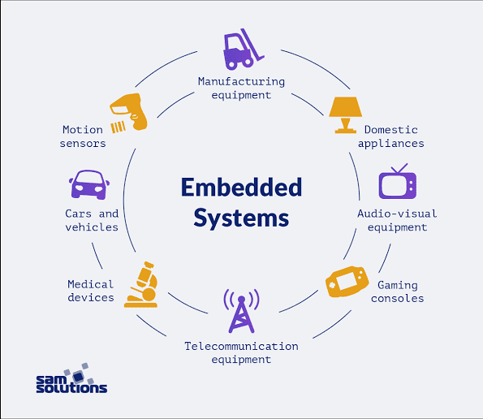

**Figure 1.2.1: Embedded Systems**

The first modern, real-time embedded computing system was the Apollo Guidance Computer, developed in the 1960s by Dr. Charles Stark Draper at the Massachusetts Institute of Technology for the Apollo Program. The Apollo Guidance Computer was designed to collect data automatically and provide mission-critical calculations for the Apollo Command Module and Lunar Module.

In 1971, Intel released the first commercially available microprocessor unit -- the Intel 4004 -- an early microprocessor that still required support chips and external memory; in 1978 the National Engineering Manufacturers Association released a standard for programmable microcontrollers, improving the embedded system design; and by the early 1980s, memory, input and output system components had been integrated into the same chip as the processor, forming a microcontroller.

The microcontroller-based embedded system would go on to be incorporated into every aspect of consumers’ daily lives, from credit card readers and cell phones, to traffic lights and thermostats.

The industry for embedded systems is expected to continue growing rapidly, driven by the continued development of Artificial Intelligence (AI), Virtual Reality (VR) and Augmented Reality (AR), machine learning, deep learning, and the [Internet of Things (IoT)](https://www.heavy.ai/learn/vast-world-of-iot). The cognitive embedded system will be at the heart of such trends as: reduced energy consumption, improved security for embedded devices, cloud connectivity and mesh networking, deep learning applications, and visualization tools with real time data.

According to a 2018 report published by QYResearch, the global market for the embedded systems industry was valued at $68.9 billion in 2017 and is expected to rise to $105.7 billion by the end of 2025.

**2. LITERATURE SURVEY**

Sk Mahammad Sorif, Dipanjan Saha, Pallav Dutta on a streetlamp control system based on the Bolt IoT platform. Using LDR with LED lights the intensity can be controlled. IR sensors utilized on roadside send signals for the LEDs to get glowing for the next specific section of the road after sensing the density of vehicles. During daytime the LDR keeps the streetlamp off until the light level is low or the light frequency is low and the LDR resistance is high.[1]

Imran Kabir, Shihab Uddin Ahamad, Mohammad Naim Uddin, Shah Mohazzem Hossain, Faija Farjana, Partha Protim Datta, Md. Raduanul Alam Riad and Mohammed Hossam-E-Haider using the GSM-GPRS shield. The whole model has the superiority to be controlled in full-automated, semi-automated and manual method. The GPRS part has the access to internet which can use the sunset and sunrise timing to allow the system to operate in full-automated method. The entire process is controlled by ATmega-328p microcontroller.[2]

Automatic Street Light Controller by Shreyas M. Paralikar, Sayali V. Mahajan, Nihal G. Kolage, Prof. Sulakshana B. Mane, illigent street lighting, also known as adaptive street lighting, slows down when no activity is detected, but flashes when movement is detected. The IR sensors Sense a movement on the road and sends signal to Arduino and thus respective LEDs are turned on. Each sensor has sequence of 3 LED’s. When 1st sensor senses the vehicle the first 3 led and turned on.[3]

Dr. Jayalakshmi B, Anjali V, Nithin Raj R, Nakul Nair, Rahul T M on IoT Based Energy Efficient Automatic Streetlight explains the external brightness of the environment is sensed by the LDR and it is given to the Arduino as input and the LEDs brightness is adjusted correspondingly as the output.[4]

Internet of Things (IoT)-based solar powered street lighting system with antivandalisation Mechanism by Archibong, Ekaette Ifiok, Ozuomba, Simeon, Ekott, Etinamabasiyaka where the system is a stand-alone solar PV system which is self-powered. It automatically switches the street light ON and OFF utilizing the light dependent resistor (LDR) and saves power by utilizing infrared sensor (IR) together with the microcontroller to dim and brighten up the LED as at when required thereby increasing the life span of the lighting module.[5]

Arduino UNO Based Visitors Counting System for Vaccination Rooms by Sakshi Gupta, Sreenitya Mandava, B. Chandrakanth Reddy, Arduino is interfaced with an ESP32 Wi-Fi modem to connect with an internet router and access the cloud server. sensors. The Arduino passes the count of the visitors in the room to the cloud.[6]

Intelligent Traffic Light System Using Computer Vision with Android Monitoring and Control by Jess Tyron G. Nodado, Hans Christian P. Morales, Ma Angelica P. Abugan, Jerick L. Olisea, Angelo C. Aralar, Pocholo James M. Loresco discussed an approach in developing traffic signaling system capable of prioritizing congested lanes based on real-time traffic density data using cctv photages and integrated with an automated and manual control ported in a mobile android-based application.[7]

A Hierarchical Framework for Intelligent Traffic Management in Smart Cities explained by Zhiyi Li, Reida Al Hassan, Mohammad Shahidehpour, Shay Bahramirad, and Amin Khodaei outcomes traffic efficiency improvements can be achieved by the utilization of a closed-loop management system. Interactive simulations are conducted in this paper to examine the performance of the proposed framework in a real-world transportation system.[8]

A hybrid Particle Swarm Optimization and Tabu Search Algorithm for adaptive traffic signal timing optimization is proposed by Maryam Alami Chentoufi and Rachid Ellaia. A novel algorithm that uses the information of the particle best neighbor in updating velocity and position, a new way of moving for each particle depending on her best historical position and whether it is included in the Tabu list. Second, we prove the effectiveness of the proposed algorithm for solving the real time traffic at isolated intersections.[9]

A Cyber-Physical System for Freeway Ramp Meter Signal Control Using Deep Reinforcement Learning in a Connected Environment by Yi Hou, Xiangyu Zhang, Peter Graf, Charles Tripp, and David Biagioni, three deep RL methods—proximal policy optimization (PPO), Ape-X deep Q-network (DQN), and asynchronous advantage actor-critic agents (A3C)—are explored for ramp meter signal control.[10]

**3. SYSTEM ANALYSIS**

* 1. **EXISTING SYSTEM**

The existing system to control traffic in main cities like Chennai, Bangalore etc is achieved using traffic police and the fixed time frames for the red and green signals. Under present scenario, traffic control is achieved by the use of a system of hand signs by traffic police personnel, traffic signals, and markings. Under current circumstances, traffic lights are set on in the different directions with fixed time delay, following a particular cycle while switching from one signal to other. This system creates unwanted and wasteful congestion on one lane while the other lanes remain vacant.

**3.2 PROPOSED SYSTEM**

The system we propose identify the density of traffic on individual lanes and thereby regulate the timing of the signals. IR transceivers count the obstructions and provide an idea about the traffic density on a particular lane and feed this response to a controller unit which will make the necessary decisions as and when required. The system will have two IR sensors for each lane. The first sensor senses the medium level traffic and the second sensor senses the high-level traffic. The software is implemented using Arduino IDE. At the low traffic time each signal is given 20 seconds for Green light indication. During the medium level traffic, the duration of the green light is increased by 20 seconds that is it lasts for 40 seconds and during the high-level traffic, the duration of the green light is increased and it lasts for 60 seconds. By implementing this automatic system for traffic control, it resolves unwanted and wasteful congestion on one side of the road.

**3.3 FEASIBILITY STUDY**

Density based automatic traffic controller system is feasible as on a longer run as it decreases traffic problems. It helps people to reach their destinations on time without so much of fuming. It will also be very helpful for ambulances which will be able to reach hospitals soon as there will be even flow of traffic and will help save lives as well.

ECONOMIC FEASIBILITY

The financial cost related to this project it feasible as it only requires sensors for installation other hardware parts are already available in the existing system.

OPERATIONAL FEASIBILITY

It will be highly useful for the people so the operational system is feasible and it is also way better than the existing system.

TECHNICAL FEASIBILITY

It is related to the feasibility of buying hardware and software. Since the existing system consists of half of the required hardware there only need of software part of the proposed system.

SCHEDULE FEASIBILITY

Based on the designed timeline chart the proposed system only requires 2-3 months for developing it without any delay.

**3.4 HARDWARE ENVIRONMENT**

The hardware requirements for Density based automatic traffic controller system is given in the below table.

**Table 3.4.1 Hardware Requirements**

|  |  |  |
| --- | --- | --- |
| S.NO: | Component Name | Count |
|  | Atmega2560 Microcontroller | 1 |
|  | Liquid Crystal Display | 1 |
|  | IR Sensor | 4 |
|  | Traffic light LEDs with Model | 2 |
|  | 5V/3A Power Supply | 1 |
|  | Power chord | 1 |

**3.5 SOFTWARE ENVIRONMENT**

The software used to program the Density based automatic traffic controller system is Arduino IDE. The open-source Arduino Software (IDE) makes it easy to write code and upload it to the board. This software can be used with any Arduino board.

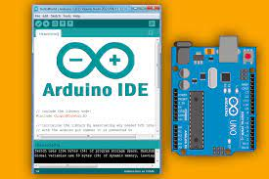

**Figure 3.5.1 Arduino IDE**

**4. SYSTEM DESIGN**

**4.1 ARCHITECTURE DIAGRAM**

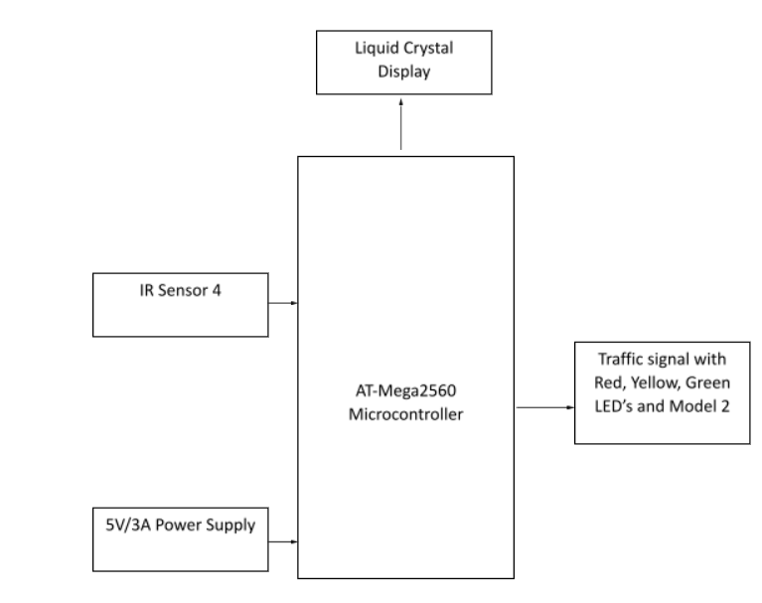

**Figure 4.1.1 Architecture Diagram**

**Description**

* The traffic signal with red, yellow, green LEDs are connected to the AT-Mega2560 Microcontroller.
* The LCD Display to show the timings and number of sensors sensed on each lane is also connected to the AT-Mega2560 Microcontroller.
* There will be two sensors in each lane, the first one is connected in the place where it detects the medium level traffic and the second sensor detects the high-level traffic.
* AT-Mega2560, commonly found in the Arduino Mega 2560 as its main microcontroller. It’s a microcontroller that executes powerful instructions in a single clock cycle. This allows it to strike a fine balance between power consumption and processing speed.
* 5V/3A power supply is used to give 5V power supply to the kit.

**4.2 ACTIVITY DIAGRAM**

An activity diagram visually presents a series of actions or flow of control in a system similar to a flowchart or a data flow diagram. Activity diagrams are often used in business process modelling. They can also describe the steps in a use case diagram. Activities modelled can be sequential and concurrent. In both cases an activity diagram will have a beginning (an initial state) and an end (a final state).

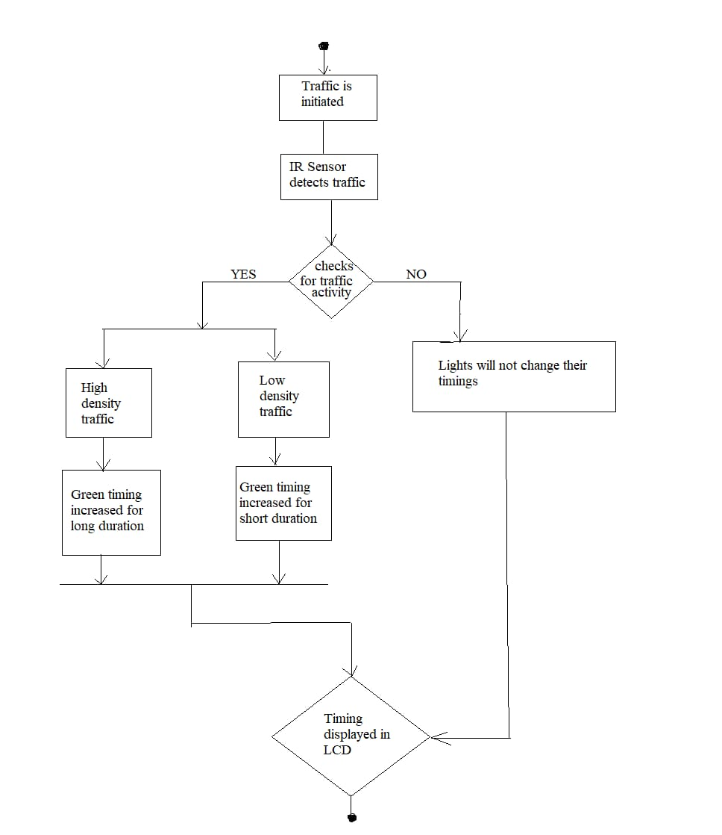

**Figure 4.2.1 Activity Diagram**

**4.3 USE CASE DIAGRAM**

A use case diagram is a dynamic or behaviour diagram in UML. Use case diagrams model the functionality of a system using actors and use cases. Use cases are a set of actions, services, and functions that the system needs to perform. In this context, a “system” is something being developed or operated, such as a website. The “actors” are people or entities operating under defined roles within the system.

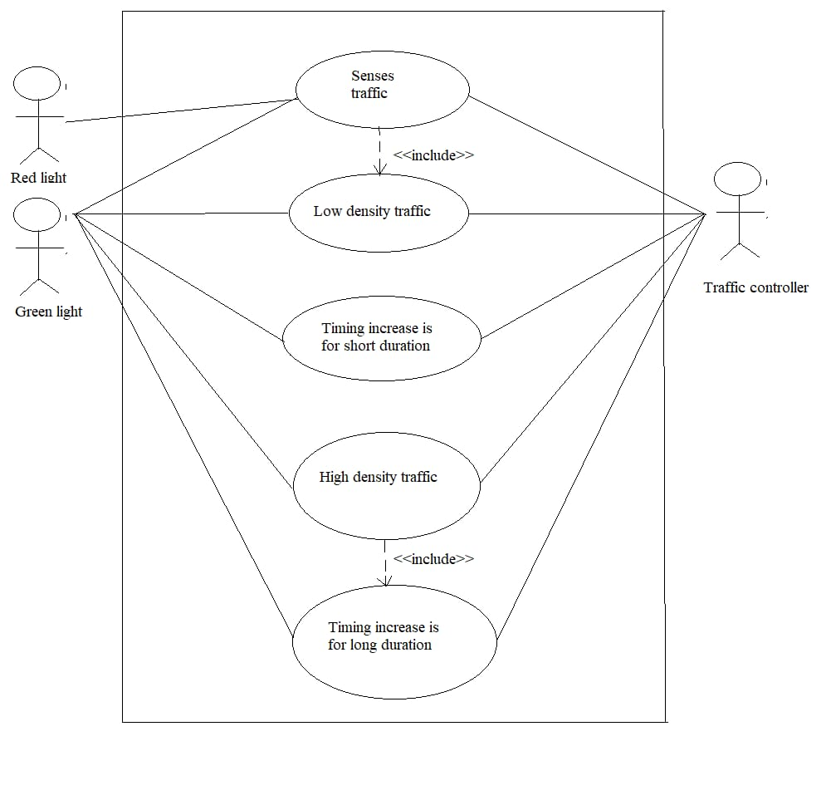

**Figure 4.3.1 Use Case Diagram**

**4.4 DATA FLOW DIAGRAM**

A data flow diagram (DFD) maps out the flow of information for any process or system. It uses defined symbols like rectangles, circles, and arrows, plus short text labels, to show data inputs, outputs, storage points and the routes between each destination. Data flowcharts can range from simple, even hand-drawn process overviews, to in-depth, multilevel DFDs that dig progressively deeper into how the data is handled. They can be used to analyse an existing system or model a new one.

**Level 0:**

* In this level, the traffic light is connected to the IR Sensors.
* The IR sensors detects the medium level traffic and high-level traffic.
* After the traffic level detection, the timings of the signals will be changed accordingly.

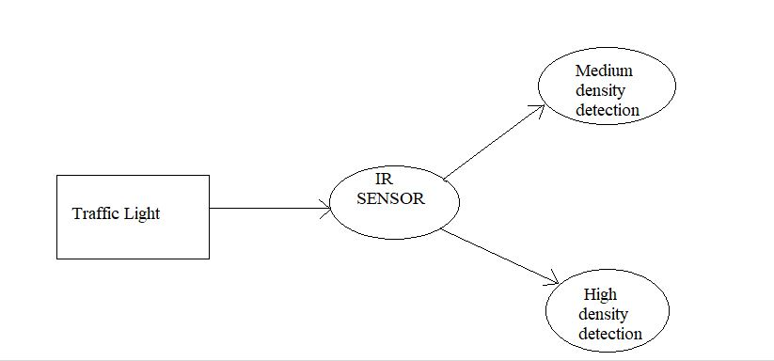

**Figure 4.4.1 Dataflow diagram level 0**

**Level 1:**

* In this level, the traffic lights which is connected to the IR Sensors detects the medium level and high-level traffic.
* After this detection, the results are shown in the LCD Display.
* If the traffic is detected as medium it will display 1 and when the traffic is in high- level it will display 2 in the LCD Display.

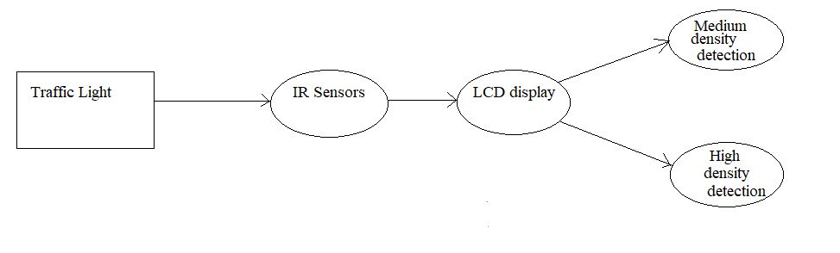

**Figure 4.4.2 Dataflow diagram level 1**

**Level 2:**

* In this level, the traffic lights change accordingly based on the low density and high-density level of traffic.
* The IR Sensors senses the traffic level and feed the output to the LCD Display.

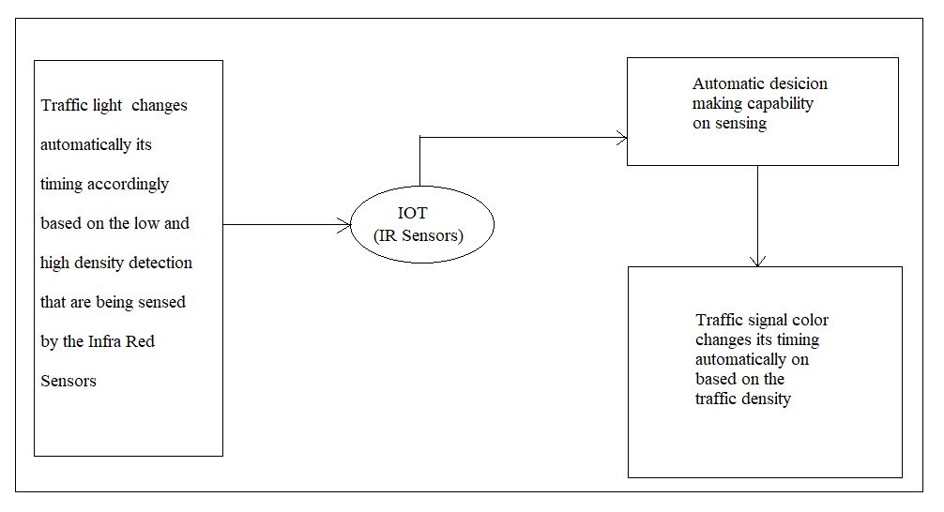

**Figure 4.4.3 Dataflow diagram level 2**

**4.5 PIN DIAGRAM**

The Arduino Mega 2560 is an open-source development board that is developed by the Arduino company. It is based on the Microchip ATmega2560P by Atmel. The Atmega2560P is an 8-bit microcontroller that comes with a built-in bootloader, which makes it very convenient to flash the board with our code. Like all Arduino boards, we can program the software running on the board using a language derived from C and C++. The easiest development environment is the Arduino IDE.

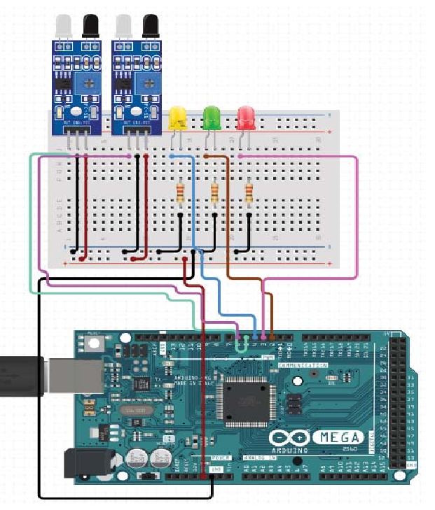

**Figure 4.5.1 Pin Diagram**

**5. SYSTEM ARCHITECTURE**

**5.1 MODULE DESIGN SPECIFICATION**

**5.1.1 ARDUINO AT-MEGA 2560**

The Arduino Mega 2560 is a microcontroller board based on the ATmega2560. It has 54 digital input/output pins (of which 14 can be used as PWM outputs), 16 analog inputs, 4 UARTs (hardware serial ports), a 16 MHz crystal oscillator, a USB connection, a power jack, an ICSP header, and a reset button. It contains everything needed to support the microcontroller; simply connect it to a computer with a USB cable or power it with an AC-to-DC adapter or battery to get started. The Mega is compatible with most shields designed for the Arduino Duemilanove or Diecimila.



**Figure 5.1.1 Arduino At-Mega 2560**

**ARDUINO SPECIFICATIONS:**

Microcontroller ATmega2560

Operating Voltage 5V

Input Voltage (Recommended) 7-12V

Input Voltage (limits) 6-20V

Digital I/O Pins 54 (of which 14 provide PWM output)

Analog Input Pins 16

DC Current per I/O Pin 40 mA

DC Current for 3.3V Pin 50 mA

Flash Memory 256 KB of which 8 KB used by bootloader

SRAM 8 KB

EEPROM 4 KB

Clock Speed 16 MHz

**ARDUINO AT-MEGA 2560 BOARD**



**Figure 5.1.2 Arduino At-Mega 2560 board**

**5.1.2 ARDUINO IR INFRARED OBSTACLE AVOIDANCE SENSOR**

The sensor module adaptable to ambient light, having a pair of infrared emitting andreceiving tubes, transmitting tubes emit infrared certain frequency, when the direction of anobstacle is detected (reflection surface), the infrared reflected is received by the receptiontube, After a comparator circuit processing, the green light is on, but the signal outputinterface output digital signal (a low-level signal), you can adjust the detection distance knobpotentiometer, the effective distance range of 2 ~ 30cm, the working voltage of 3.3V- 5V.Detection range of the sensor can be obtained by adjusting potentiometer, with littleinterference, easy to assemble, easy to use features, can be widely used in robot obstacleavoidance, avoidance car, line count, and black and white line tracking and many otheroccasions.



**Figure 5.1.3 IR Sensor**

**SPECIFICATIONS:**

* When the module detects an obstacle in front of the signal, the green indicator lights on the board level, while the OUT port sustained low signal output, the module detects the distance 2 ~ 30cm, detection angle 35 °, the distance can detect potential is adjusted clockwise adjustment potentiometer, detects the distance increases; counter clockwise adjustment potentiometer, reducing detection distance.
* The sensor active infrared reflection detection, target reflectivity and therefore the shape is critical detection distance. Where the minimum detection distance black, white, maximum; small objects away from a small area, a large area from the Grand.
* The sensor module output port OUT port can be directly connected to the microcontroller IO can also be directly drive a 5V relay; Connection: VCC-VCC; GND-GND; OUT-IO.
* Comparators LM393, stable.
* The module can be 3-5V DC power supply. When the power is turned on, the red power indicator lights.
* With the screw holes 3mm, easy fixed installation.
* Board size: 3.2CM * 1.4CM.
* Each module has been shipped threshold comparator voltage adjusted by potentiometer good, non-special case, do not adjustable potentiometer.

**MODULE INTERFACE DESCRIPTION**

* VCC: 3.3V-5V external voltage (can be directly connected to 5v and 3.3v MCU)
* GND: GND External
* OUT: small board digital output interface (0 and 1)

**5.1.3 LIGHT EMITTING DIODES (LEDs)**

LEDs are usually built on an n-type substrate, with an electrode attached to the p-type layer deposited on its surface. P-type substrates, while less common, occur as well. Many commercial LEDs, especially GaN/InGaN, also use sapphire substrate. LEDs have come a long way and currently they are widely used in many applications. In future, I believe research will continue for high intensity LEDs, even though heat dissipation is an issue.



**Figure 5.1.4 Light Emitting Diodes (LEDs)**

**APPLICATIONS:**

LED have a lot of applications. Following are few examples.

* Devices, medical applications, clothing, toys
* Remote Controls (TVs, VCRs)
* Lighting
* Indicators and signs
* Optoisolators and optocouplers

**ADVANTAGES:**

* LEDs produce more light per watt than incandescent bulbs; this is useful in battery powered or energy-saving devices.
* LEDs can emit light of an intended color without the use of color filters that traditional lighting methods require. This is more efficient and can lower initial costs.
* The solid package of the LED can be designed to focus its light. Incandescent and fluorescent sources often require an external reflector to collect light and direct it in a usable manner.
* When used in applications where dimming is required, LEDs do not change their color tint as the current passing through them is lowered, unlike incandescent lamps, which turn yellow.

**DISADVANTAGES:**

* LED performance largely depends on the ambient temperature of the operating environment. Over-driving the LED in high ambient temperatures may result in overheating of the LED package, eventually leading to device failure. Adequate heat-sinking is required to maintain long life.
* LEDs must be supplied with the correct current. This can involve series resistors or current-regulated power supplies.
* LEDs do not approximate a "point source" of light, so they cannot be used in applications needing a highly collimated beam. LEDs are not capable of providing divergence below a few degrees. This is contrasted with commercial ruby lasers with divergences of 0.2 degrees or less. However this can be corrected by using lenses and other optical devices.

**5.1.4 LCD DISPLAY**

The term [LCD stands for liquid crystal display](https://www.elprocus.com/difference-alphanumeric-display-and-customized-lcd/). It is one kind of electronic display module used in an extensive range of applications like various circuits & devices like mobile phones, calculators, computers, TV sets, etc. These displays are mainly preferred for multi-segment [light-emitting diodes](https://www.elprocus.com/light-emitting-diode-led-working-application/) and seven segments. The main benefits of using this module are inexpensive; simply programmable, animations, and there are no limitations for displaying custom characters, special and even animations, etc.

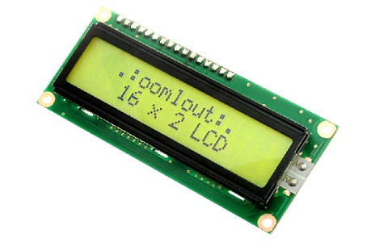

**Figure 5.1.5 16 X 2 LCD Display**

**LCD DISPLAY 16 X 2 PIN DIAGRAM:**

The 16×2 LCD pinout is shown below.

* Pin1 (Ground/Source Pin): This is a GND pin of display, used to connect the GND terminal of the microcontroller unit or power source.
* Pin2 (VCC/Source Pin): This is the voltage supply pin of the display, used to connect the supply pin of the power source.
* Pin3 (V0/VEE/Control Pin): This pin regulates the difference of the display, used to connect a changeable POT that can supply 0 to 5V.
* Pin4 (Register Select/Control Pin): This pin toggles among command or data register, used to connect a microcontroller unit pin and obtains either 0 or 1

(0 = data mode, and 1 = command mode).

* Pin5 (Read/Write/Control Pin): This pin toggles the display among the read or writes operation, and it is connected to a microcontroller unit pin to get either 0 or 1 (0 = Write Operation, and 1 = Read Operation).
* Pin 6 (Enable/Control Pin): This pin should be held high to execute Read/Write process, and it is connected to the microcontroller unit & constantly held high.
* Pins 7-14 (Data Pins): These pins are used to send data to the display. These pins are connected in two-wire modes like 4-wire mode and 8-wire mode. In 4-wire mode, only four pins are connected to the microcontroller unit like 0 to 3, whereas in 8-wire mode, 8-pins are connected to microcontroller unit like 0 to 7.
* Pin15 (+ve pin of the LED): This pin is connected to +5V
* Pin 16 (-ve pin of the LED): This pin is connected to GND.

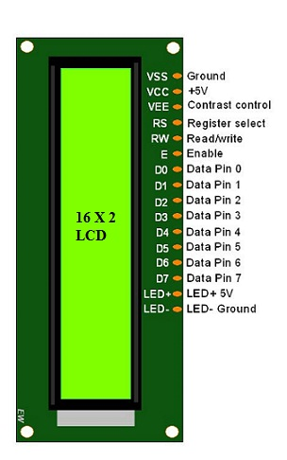

**Figure 5.1.6 LCD Display Pin diagram**

**5.2 ALGORITHMS**

**FUZZY LOGIC ALGORITHM**

The application of fuzzy logic principles in embedded systems enables solving problems that would be difficult or even impossible to solve if mathematical models were used. The intuitive nature of the fuzzy-based system design saves engineers time and reduces costs by shortening product development cycles and making system maintenance and adjustments easier.

Fuzzy systems are generally employed on embedded systems based on field programmable gate array (FPGA) and powerful microcontrollers in different applications such as home power management, image quality assessment, emergency-care platform and others [3], [4], [5], [6], [7], [8]. However, among the different fuzzy logic models, the type-1 compared to other techniques that deal with nonlinear, imprecise or missing data is easier to design and to implement on limited hardware that characterize an embedded system.

The goal of this work is to present a detailed type-1 fuzzy logic algorithm developed in C language to be used in 8-bit microcontrollers and to be adaptable to different applications. It also shows a rigorous comparison between the proposed algorithm and type-1 fuzzy conventional algorithm, in which the accuracy, the processing speed and especially the low amount of memory necessary for the execution of the proposed code are highlighted, a resource very limited in low-cost embedded systems.

**6. SYSTEM IMPLEMENTATION**

**6.1 CODING**

#include <LiquidCrystal.h>

LiquidCrystal lcd(13, 12, 11, 10, 9, 8);

#define splash splash1

int g[2] = {49, 43 };

int y[2] = {51, 45 };

int r[2] = {53, 47 };

#define s1ir1 A0

#define s1ir2 A1

#define s2ir1 A2

#define s2ir2 A3

int states[2] = { HIGH, HIGH};

int totalDevices = 2;

unsigned long previousMillis = 0;

unsigned long previousMillis1 = 0;

long t = 20, prevt;

long tt1 = 1000;

int tset, a;

int red1Status, yellow1Status, yellow2Status, red2Status, aStat ;

int s1ir1_r, s1ir2_r, s2ir1_r, s2ir2_r;

int dens1, dens2;

void setup() {

lcd.begin(16, 2);

lcd.setCursor(0, 0);

Serial.begin(9600);

LcDSet();

splash(0, "Signal");

splash(1, "Initializing");

setupPinsMode();

delay(2000);

lcd.clear();

}

void LcDSet()

{

lcd.begin(16, 2);

splash(0, "Smart Traffic");

splash(1, "Control");

delay(2000);

lcd.clear();

}

void setupPinsMode() {

pinMode(s1ir1, INPUT);

pinMode(s1ir2, INPUT);

pinMode(s2ir1, INPUT);

pinMode(s2ir2, INPUT);

// setup Pin mode as output.

for (int i; i < totalDevices; i++) {

Serial.println();

pinMode(g[i], OUTPUT);

digitalWrite(g[i], HIGH);

delay(100);

Serial.println();

pinMode(y[i], OUTPUT);

digitalWrite(y[i], HIGH);

delay(100);

Serial.println();

pinMode(r[i], OUTPUT);

digitalWrite(r[i], HIGH);

delay(100);

}

delay(1000);

for (int i; i < totalDevices; i++) {

Serial.println();

pinMode(g[i], OUTPUT);

digitalWrite(g[i], LOW);

delay(100);

Serial.println();

pinMode(y[i], OUTPUT);

digitalWrite(y[i], LOW);

delay(100);

Serial.println();

pinMode(r[i], OUTPUT);

digitalWrite(r[i], LOW);

delay(100);

}

}

void loop()

{

timer();

s1ir1_r = digitalRead(s1ir1);

s1ir2_r = digitalRead(s1ir2);

s2ir1_r = digitalRead(s2ir1);

s2ir2_r = digitalRead(s2ir2);

if (s1ir1_r ) {

dens1 = 1;

if (s1ir2_r ) {

dens1 = 2;

}

}

else {

dens1 = 0;

}

if (!s2ir1_r ) {

dens2 = 1;

if (!s2ir2_r ) {

dens2 = 2;

}

}

else {

dens2 = 0;

}

lcd.setCursor(0, 0);

lcd.print("Traffic Density");

lcd.setCursor(0, 1);

lcd.print(" ");

lcd.setCursor(0, 1);

lcd.print(dens1);

lcd.setCursor(5, 1);

lcd.print(" ");

lcd.setCursor(5, 1);

lcd.print(dens2);

lcd.setCursor(14, 1);

lcd.print(" ");

lcd.setCursor(14, 1);

lcd.print(a);

delay(300);

}

void red1()

{

digitalWrite(r[0], HIGH);

digitalWrite(r[1], LOW);

digitalWrite(y[0], LOW);

digitalWrite(y[1], LOW);

digitalWrite(g[0], LOW);

digitalWrite(g[1], HIGH);

}

void red2()

{

digitalWrite(r[0], LOW);

digitalWrite(r[1], HIGH);

digitalWrite(y[0], LOW);

digitalWrite(y[1], LOW);

digitalWrite(g[0], HIGH);

digitalWrite(g[1], LOW);

}

void yellow()

{

digitalWrite(r[0], LOW);

digitalWrite(r[1], LOW);

digitalWrite(y[0], HIGH);

digitalWrite(y[1], HIGH);

digitalWrite(g[0], LOW);

digitalWrite(g[1], LOW);

}

void green1()

{

}

void green2()

{

}

void timer()

{

unsigned long currentMillis = millis();

unsigned long currentMillis1 = millis();

if (tset == 0)

{

tset = 1;

a = t;

prevt = t;

}

if (currentMillis - previousMillis >= t) {

// save the last time you blinked the LED

previousMillis = currentMillis;

}

if (currentMillis1 - previousMillis1 >= tt1) {

// save the last time you blinked the LED

previousMillis1 = currentMillis1;

if (aStat == 0)

{ aStat = 1;

red1();

red1Status = 1;

t = 5;

}

if (a <= 0)

{

a = t;

if (a >= (t - 2) && red1Status == 0)

{

red1();

red1Status = 1;

red2Status = 0;

yellow1Status = 0;

t = 5;

}

else if (a >= (t - 2) && yellow1Status == 0)

{

yellow();

yellow1Status = 1;

red2Status = 0;

t = prevt;

if (dens2 == 2 ) {

t = 60;

}

else if (dens2 == 1 ) {

t = 40;

}

else {

t = 20;

}

}

else if (a >= (t - 2) && red2Status == 0)

{

red2();

yellow2Status = 0;

red2Status = 1;

red1Status = 1;

t = 5;

}

else if (a >= (t - 2) && yellow2Status == 0)

{

yellow();

yellow2Status = 1;

red1Status = 0;

t = prevt;

if (dens1 == 2) {

t = 60;

}

else if (dens1 == 1 ) {

t = 40;

}

else {

t = 20;

}

}

}

else

{

a--;

}

}

}

**7. SYSTEM TESTING**

**7.1 UNIT TESTING**

Unit testing involves the testing of each unit or an individual component of the software application. It is the first level of functional testing. The aim behind unit testing is to validate unit components with its performance. A unit is a single testable part of a software system and tested during the development phase of the application software. The purpose of unit testing is to test the correctness of isolated code. A unit component is an individual function or code of the application. White box testing approach used for unit testing and usually done by the developers. Whenever the application is ready and given to the Test engineer, he/she will start checking every component of the module or module of the application independently or one by one, and this process is known as **Unit testing** or **components testing.**

**7.2 INTEGRATION TESTING**

Integration testing is the second level of the software testing process comes after unit testing. In this testing, units or individual components of the software are tested in a group. The focus of the integration testing level is to expose defects at the time of interaction between integrated components or units. [Unit testing](https://www.javatpoint.com/unit-testing) uses modules for testing purpose, and these modules are combined and tested in integration testing. The Software is developed with a number of software modules that are coded by different coders or programmers. The goal of integration testing is to check the correctness of communication among all the modules. Once all the components or modules are working independently, then we need to check the data flow between the dependent modules is known as **integration testing.**

**7.3 TEST CASES AND REPORTS**

**Table 7.3 Test Cases and Reports**

|  |  |  |  |  |
| --- | --- | --- | --- | --- |
| **S.NO** | **TEST CASE** | **EXPECTED RESULT** | **ACTUAL RESULT** | **PASS/FAIL** |
| 1 | No vehicles sensed by the IR Sensors. | Green signal should glow for 20 seconds. | Green light glowed for 20 seconds. | Pass |
| 2 | First sensor which is placed to detect medium level traffic is sensed. | Green light should glow for 40 seconds. | Green light glowed for 40 seconds. | Pass |
| 3 | First as well as second sensor which is placed to detect high level traffic is sensed. | Green light should glow for 60 seconds. | Green light glowed for 60 seconds. | Pass |

**8. CONCLUSION**

**8.1 RESULTS & DISCUSSION**

Density based automatic traffic controller system can help the busy cities to get rid of the high-level traffic. The main advantage of the system is it is automated and does not require any man power. When there is no traffic detected the traffic lights will run undisturbed. When the medium level traffic and high-level traffic is detected, the time will change accordingly.

**8.2 CONCLUSION AND FUTURE ENHANCEMENT**

**CONCLUSION**

In this paper, an automatic way for regulating traffic using the IR sensors is proposed. The components used in the project, like Arduino and sensors are slowly becoming an indispensable part of our daily routines. This program can be adapted by the larger cities and the timings can be changed based on the traffic condition on that city. This method of controlling traffic can reduce man hours and yield great impacts in the society.

**FUTURE ENHANCEMENT**

In future we can power this project using solar panels which will create a great impact in the society. We can also introduce a module in which the ambulances can easily passes the traffic signal by giving the control of traffic signal to ambulance drivers. The timings for clearing the medium and high-level traffic can be changed according to the city.

**APPENDICES**

**A.1 SAMPLE SCREENS**

**A.1.1 DENSITY BASED TRAFFIC CONTROLLER SYSTEM**

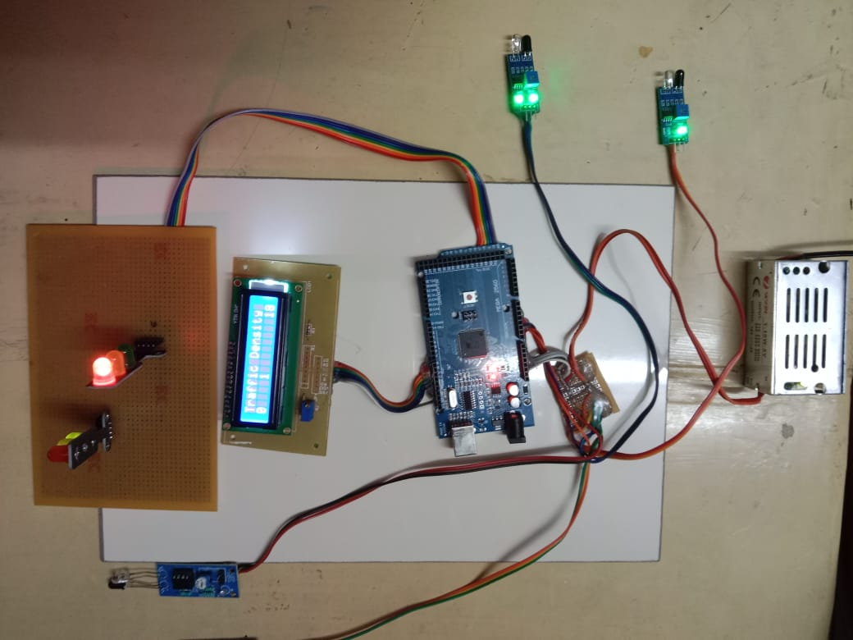

**Figure A.1.1 Density based traffic controller system**

**A.1.2 LCD DISPLAY DURING LOW LEVEL TRAFFIC**

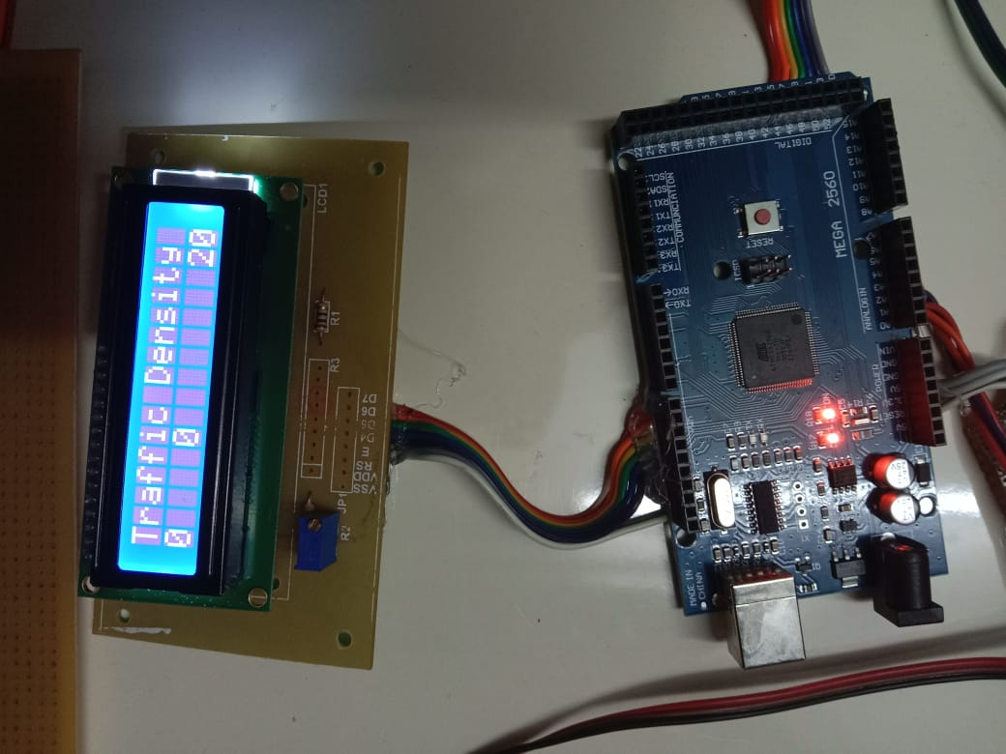

**Figure A.1.2 LCD Display during low level traffic**

**A.1.3 LCD DISPLAY DURING MEDIUM LEVEL TRAFFIC**

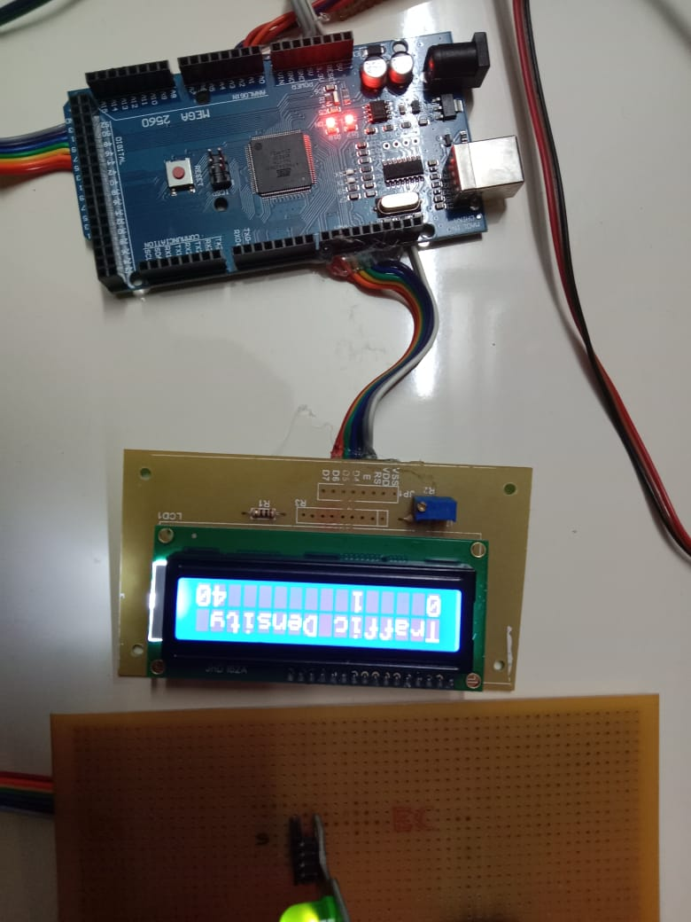

**Figure A.1.3 LCD Display during medium level traffic**

**A.1.4 LCD DISPLAY DURING HIGH LEVEL TRAFFIC**

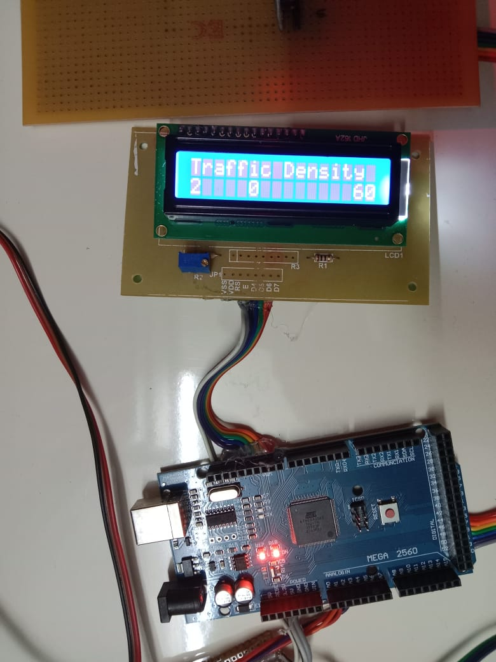

**Figure A.1.4 LCD display during high level traffic.**

**REFERENCES**

1. Sk Mahammad Sorif, Dipanjan Saha, Pallav Dutta, “Smart Street Light Management System with Automatic Brightness Adjustment Using Bolt IoT Platform”, 2021 IEEE International IOT, Electronics and Mechatronics Conference.
2. Imran Kabir, Shihab Uddin Ahamad, Mohammad Naim Uddin, Shah Mohazzem Hossain, Faija Farjana, Partha Protim Datta, Md. Raduanul Alam Riad and Mohammed Hossam-E-Haider, “GSM-GPRS Based Smart Street Light”, 2021 2nd International Conference on Robotics, Electrical and Signal Processing Techniques.
3. Shreyas M. Paralikar, Sayali V. Mahajan, Nihal G. Kolage, Prof. Sulakshana B. Mane, “Automatic Street Light Controller”, International Research Journal of Engineering and Technology (IRJET), Volume: 07 Issue: 02| Feb 2020.
4. Dr. Jayalakshmi B, Anjali V, Nithin Raj R, Nakul Nair, Rahul T M, “IoT Based Energy Efficient Automatic Streetlight”, Proceedings of the International Conference on Intelligent Computing and Control Systems.
5. Archibong, Ekaette Ifiok, Ozuomba, Simeon, Ekott, Etinamabasiyaka, “Internet of Things (IoT)-based, Solar Powered Street Light System with Antivandalisation Mechanism”,2020 International Conference in Mathematics, Computer Engineering and Computer Science.
6. Sakshi Gupta, Sreenitya Mandava, B. Chandrakanth Reddy, “Arduino UNO Based Visitors Counting System for Vaccination Rooms”, International Research Journal of Engineering and Technology (IRJET), Volume: 08 Issue: 11| Nov 2021.
7. Jess Tyron G. Nodado, Hans Christian P. Morales, Ma Angelica P. Abugan, Jerick L. Olisea, Angelo C. Aralar, Pocholo James M. Loresco, “Intelligent Traffic Light System Using Computer Vision with Android Monitoring and control”, Proceedings of TENCON 2018 – 2018 IEEE Region 10 Conference.
8. Zhiyi Li, Reida Al Hassan, Mohammad Shahidehpour, Shay Bahramirad, and Amin Khodaei, “A Hierarchical Framework for Intelligent Traffic Management in Smart Cities”, IEEE TRANSACTIONS ON SMART GRID, VOL. 10, NO. 1, JANUARY 2019.
9. Maryam Alami Chentoufi and Rachid Ellaia, “A Hybrid Particle Swarm Optimization and Tabu Search algorithm for adaptive traffic signal timing optimization”, 2018 IEEE International IOT, Electronics and Mechatronics Conference.
10. Yi Hou, Xiangyu Zhang, Peter Graf, Charles Tripp, and David Biagioni, “A Cyber-Physical System for Freeway Ramp Meter Signal Control Using Deep Reinforcement Learning in a Connected Environment”, 2021 IEEE Intelligent transportation Systems Conference (ITSC) Indianapolis, USA. September 19-21, 2021.
11. SayaliArkade, Akshada Mohite, Rutuj, Vikas, “IoT Based Street Lights for Smart City” International Journal for Research in Applied Science & Engineering Technology (IJRASET), Volume 4 Issue XII, December 2016.
12. Ritisha Salvi, Shraddha Margaj, Kavita Mate1, Bhakti Aher, Smart Street Light Using Arduino Uno Microcontroller” International Journal of Innovative Research in Computer and Communication Engineering, Vol. 5, Issue 3, March 2017.
13. Parkash, Prabu V, Dandu Rajendra, “Internet of Things Based Intelligent Street Lighting System for Smart City” International Journal of Innovative Research in Science, Engineering and Technology, Vol. 5, Issue 5, May 2016.
14. Jeetendra Swami, Himanshu Patel, Krishna Patel and Ms. Nisha Bhalse, “IoT Based Street Light Automation System” International Journal of Trend in Research and Development, Volume 6(2), ISSN:2394-9333.
15. Arthi, W.Lydiapreethi, and B. Gunasundari,“IOT Based Smart LED Street Lighting System” IJRTI | Volume 2, Issue 4 | ISSN: 2456-3315.
16. A. K. Tripathy, A. K. Mishra and T. K. Das, "Smart lighting: Intelligent and weather adaptive lighting in street lights using IOT," 2017 International Conference on Intelligent Computing, Instrumentation and Control Technologies (ICICICT), Kerala, India, 2017, pp. 1236-1239, doi: 10.1109/ICICICT1.2017.8342746.
17. M. Saifuzzaman, N. N. Moon and F. N. Nur, "IoT based street lighting and traffic management system," 2017 IEEE Region 10 Humanitarian Technology Conference (R10-HTC), Dhaka, Bangladesh, 2017, pp. 121-124, doi: 10.1109/R10- HTC.2017.8288921.
18. A. Suzdalenko and I. Galkin, “Choice of power and control hardware for smart LED luminary,” in Proceeding of the 12th IEEE Biennial Baltic Electronics Conference, Tallinn, Estonia, pp. 331-334, 2010.
19. Monika R. Kodali and S. Yerroju, "Energy efficient smart street light," 2017 3rd International Conference on Applied and Theoretical Computing and Communication Technology (iCATccT), Tumkur, India, 2017, pp. 190-193, doi: 10.1109/ICATCCT.2017.8389131.
20. B. Abinaya, S. Gurupriya and M. Pooja, "Iot based smart and adaptive lighting in street lights," 2017 2nd International Conference on Computing and Communications Technologies (ICCCT), Chennai, 2017, pp. 195-198, doi: 10.1109/ICCCT2.2017.7972267.
21. Dr.A.S.C.S.SASTRY, K.A.S.K. Bhargav, K. Surya Pavan, M.Narendra “Smart Street Light System using IoT” International Research Journal of Engineering and Technology (IRJET) e-ISSN: 2395-0056, p-ISSN: 2395-0072, Volume: 07 Issue: 03 | Mar 2020.
22. S. Rehan and R. Singh, "Industrial and Home Automation, Control, Safety and Security System using Bolt IoT Platform," 2020 International Conference on Smart Electronics and Communication (ICOSEC), Trichy, India, 2020, pp. 787-793, doi:10.1109/ICOSEC49089.2020.9215345.
23. P. P. F. Dheena, G. S. Raj, G. Dutt and S. V. Jinny, "IOT based smart street light management system," 2017 IEEE International Conference on Circuits and Systems (ICCS), Thiruvananthapuram, India, 2017,pp. 368-371, doi: 10.1109/ICCS1.2017.8326023.